Insertando imagen...

ACME-SF

G1.007

**Planning and progress report**

15/2/2024



# Cover

|  |  |
| --- | --- |
| **Repository:** <https://github.com/Pablo-Caballero-Maria/Acme-One-24.1.0-C1.07> | |
| **Student #1**  **ID:** 31878881F  **UVUS:**  pabcabmar3  **Name:** Caballero María, Pablo **Roles:** manager, developer | **Student #2**  **ID Number:**49034820Q  **UVUS:** mararnmon  **Name:** Arnáiz Montero, Marco Antonio  **Roles:** developer, operator |
| **Student #3**  **ID Number:** 77865211E  **UVUS:**  alfalolan  **Name:** Alonso Lanzarán, Alfonso Luis  **Roles:** developer, tester | **Student #4**  **ID Number:** 53932912M  **UVUS:** albsanmim  **Name:** Sánchez Mimbrero, Alberto  **Roles:** developer |
| **Student #5**  **ID Number:** 48123111G  **UVUS:** juagarcar4  **Name:** Garcia Carballo, Juan  **Roles:** developer |  |

Table of contents

Cover 1

Executive summary 2

Revision table 2

Introduction 2

Contents 3

Planning chapter: 3

Progress chapter 6

Conclusions 6

Bibliography 6

# Executive summary

The lifecycle of the Acme-SF project just started. Thus, it is currently in its first stages: the repository has recently been set up and minor changes have been made. Most of the time spent in this deliverable was for having the first contact with the technologies asked, preparing the workspace, analyzing the WIS requirements and fulfilling the required documentation.

# Revision table

|  |  |  |
| --- | --- | --- |
| Number | Date(dd/mm/yyyy) | Description |
| 1.0 | 15/02/2024 | Document done in its entirety, reviewed by peers. No major errors were found. |

# Introduction

The purpose of this document is to provide a detailed planning and progress report of the first delivery of the project “Acme-SF-D01”, for the subject “Design and Testing 2”. This is divided into two chapters: planning (specifying the requirements set for this delivery, assignees, roles, planned time, actual time, budget estimation...) and progress (assignees performances, conflicts arisen, actual cost in contrast to the estimations...).

# Contents

## Planning chapter:

List of taks for the first deliverable:

|  |  |  |  |  |
| --- | --- | --- | --- | --- |
| Title and description | Assignees | role | Estimate | Invested time |
| Task S02-001/F: Modify the anonymous menu | Arnáiz Montero, Marco Antonio | developer | 10 | 15 |
| Task 017: Attend to classes | Arnáiz Montero, Marco Antonio | developer | 720 | 720 |
| Task S02-002/M1: Produce an analysis report | Arnáiz Montero, Marco Antonio | developer | 30 | 30 |
| Task S02-003/M2: Produce a planning and progress report | Arnáiz Montero, Marco Antonio | developer | 40 | 45 |
| Task G07: Produce a configuration report | Arnáiz Montero, Marco Antonio | developer | 20 | 30 |
| Task 029: Create the delivery | Arnáiz Montero, Marco Antonio | operator | 10 | 20 |

Next, there are screenshots that shows different moments of the delivery development.

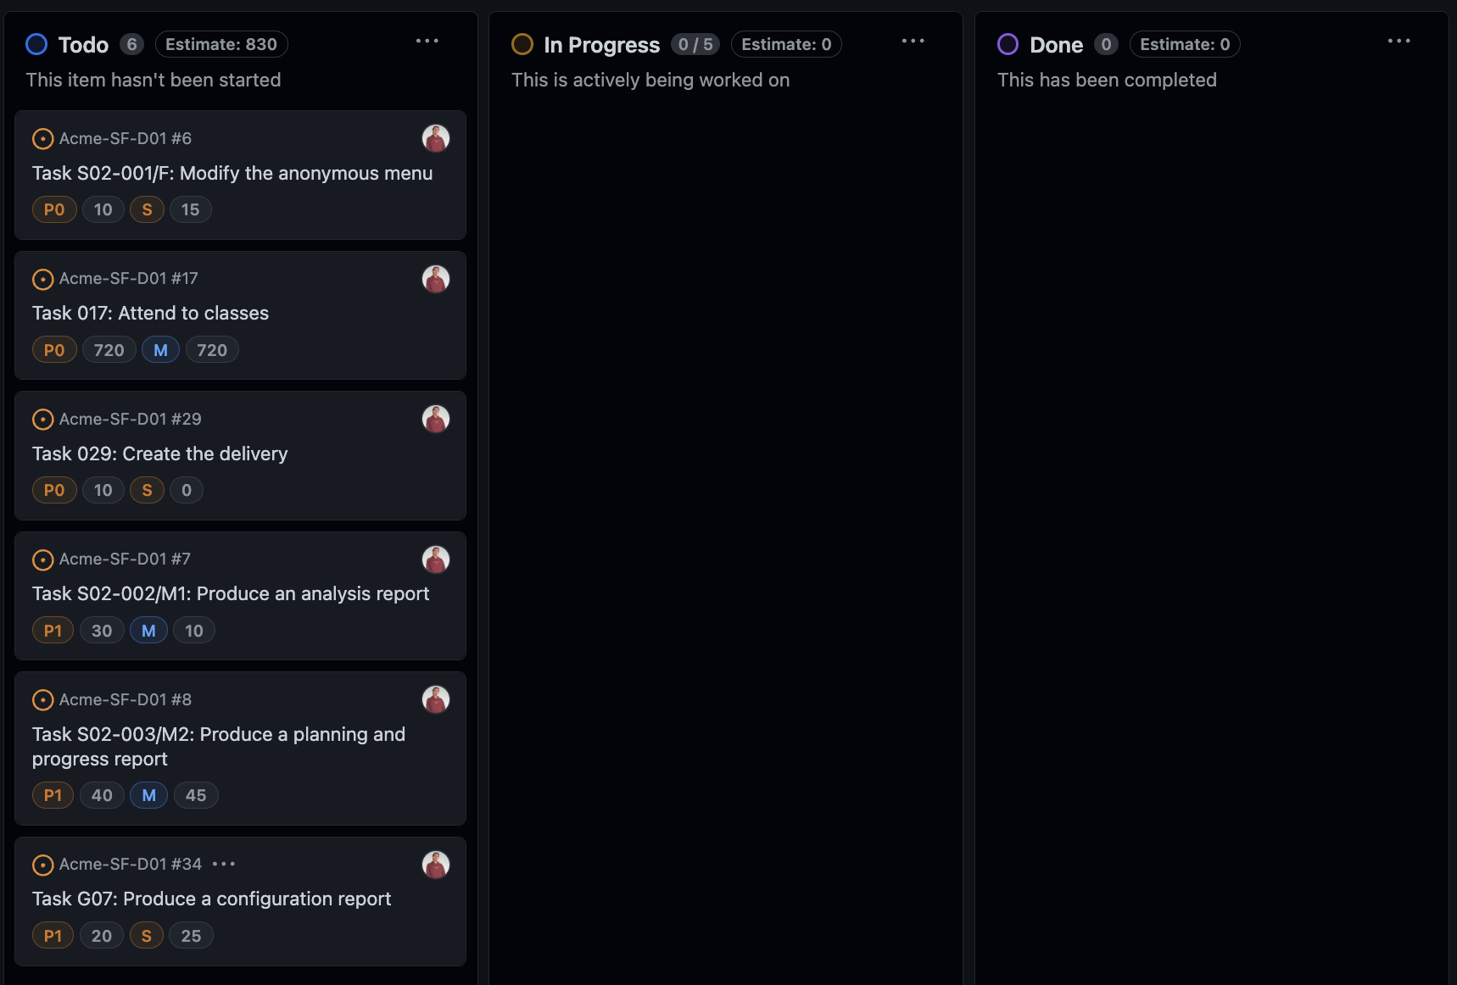

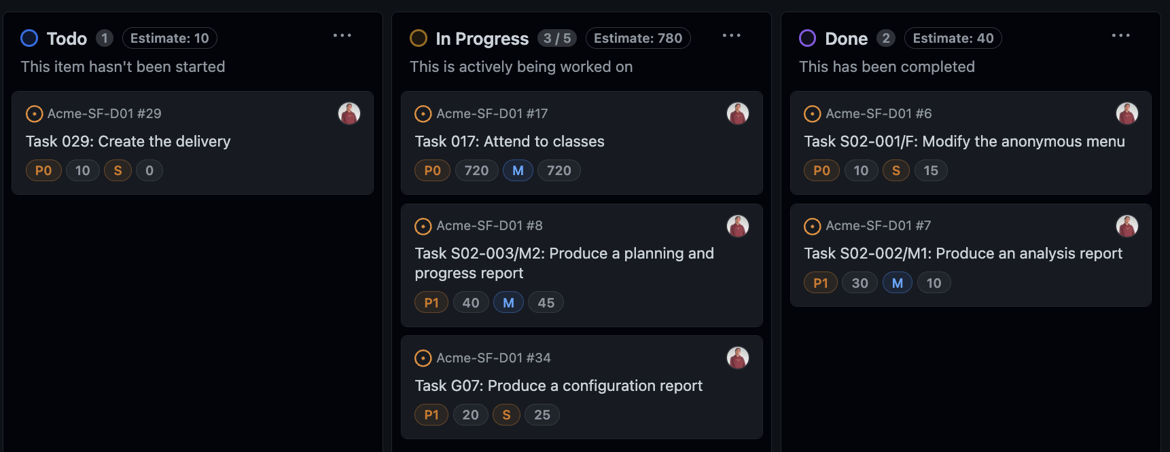

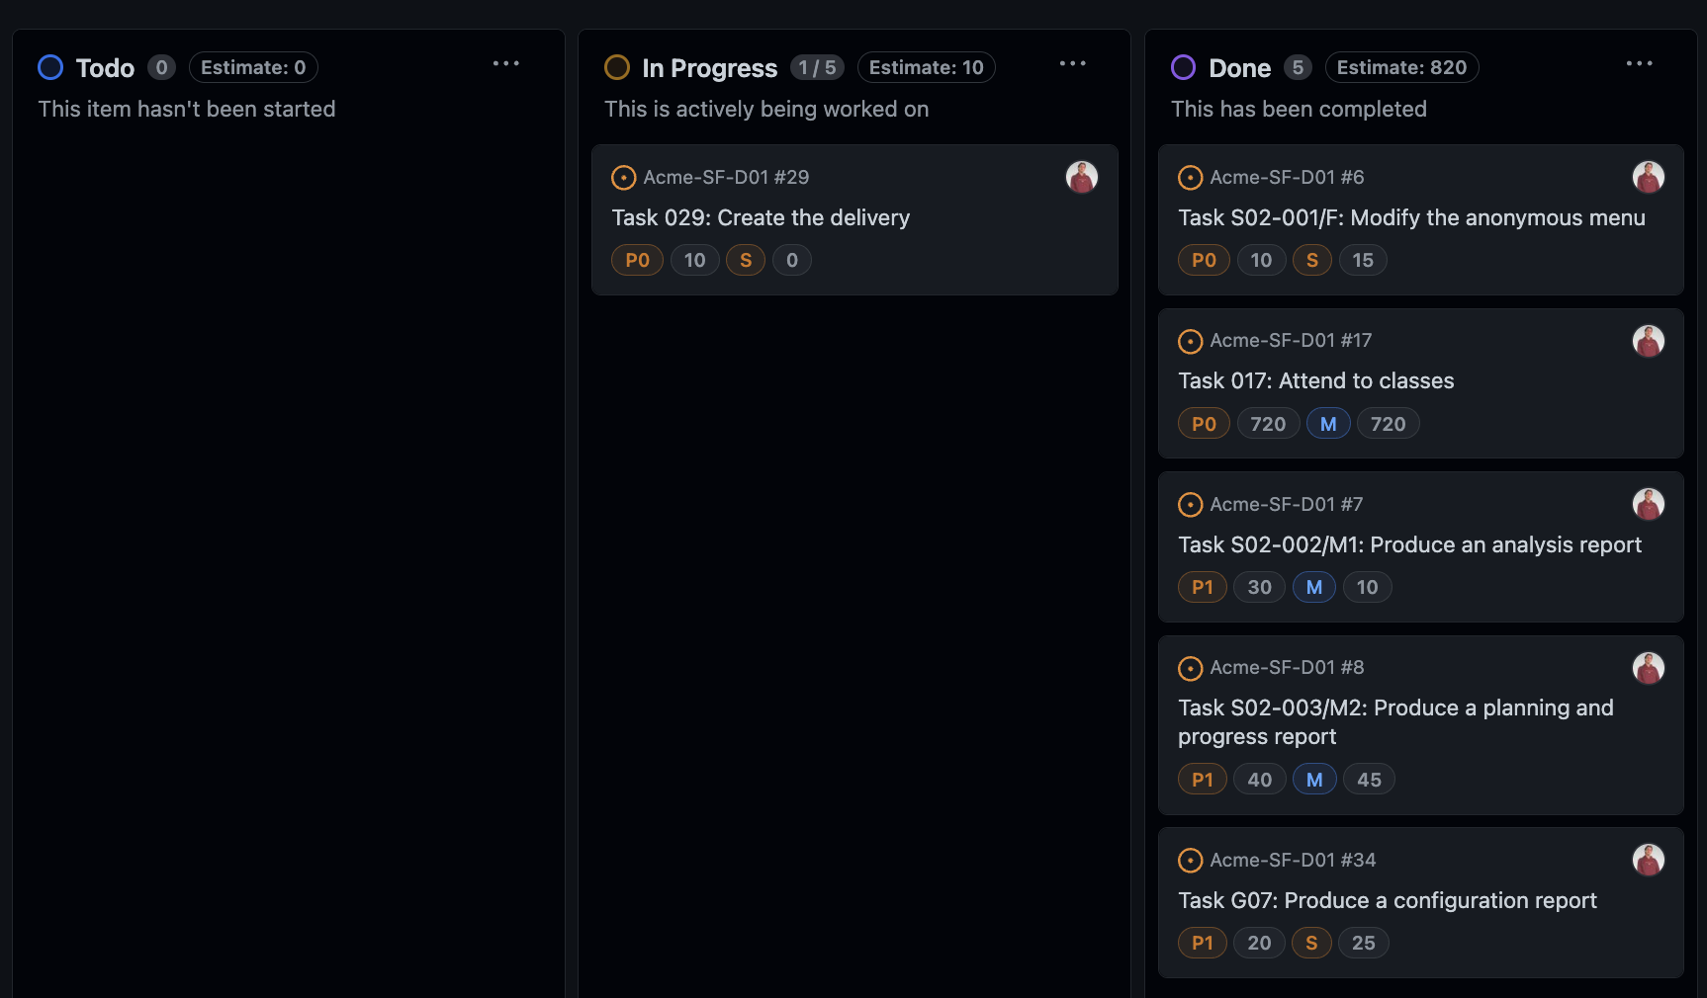

Next, it is sho the calculation of the estimated budget:

|  |  |  |  |  |  |
| --- | --- | --- | --- | --- | --- |
| Title and description | Assignees | role | Estimate (minutes) | Cost/minute | Total/task  (euros) |
| Task S02-001/F: Modify the anonymous menu | Arnáiz Montero, Marco Antonio | developer | 10 | 0.33€ | 3.3€ |
| Task 017: Attend to classes | Arnáiz Montero, Marco Antonio | developer | 720 | 0.33€ | 237.6€ |
| Task S02-002/M1: Produce an analysis report | Arnáiz Montero, Marco Antonio | developer | 30 | 0.33€ | 9.9€ |
| Task S02-003/M2: Produce a planning and progress report | Arnáiz Montero, Marco Antonio | developer | 40 | 0.33€ | 13.2€ |
| Task G07: Produce a configuration report | Arnáiz Montero, Marco Antonio | developer | 20 | 0.33€ | 6.6€ |
| Task 029: Create the delivery | Arnáiz Montero, Marco Antonio | operator | 10 | 0.33€ | 3.3€ |
|  |  |  |  | **Total** | **303.9€** |

Equipment cost = 950 €

Total cost = 1253.7€

Considering a lineal amortization over 3 years, the yearly amortization cost is 417.9€

## Progress chapter

Progress Records:

I received a 1 which is the best value because I have completed all my tasks in an effective way.

Conflicts:

Intentionally blank.

Real Cost:

|  |  |  |  |  |
| --- | --- | --- | --- | --- |
| Title | Invested time (min) | role | € per hour | Budget of the task |
| Task S02-001/F: Modify the anonymous menu | 15 | developer | 20 | 5€ |
| Task 017: Attend to classes | 720 | developer | 20 | 240€ |
| Task S02-002/M1: Produce an analysis report | 30 | developer | 20 | 10€ |
| Task S02-003/M2: Produce a planning and progress report | 45 | developer | 20 | 14.85€ |
| Task G07: Produce a configuration report | 30 | developer | 20 | 10€ |
| Task 029: Create the delivery | 20 | operator | 20 | 6.6€ |
|  |  |  | **Total** | **286.45** |

Equipment cost = 950 €

Total cost = 1236.7€

Considering a lineal amortization over 3 years, the yearly amortization cost is 412.23€

# Conclusions

In summary, the Acme-SF project is in its initial stages, focusing on repository setup and preliminary tasks. The report, reviewed with no major errors, highlights efforts in technology familiarization and documentation. Notably, Juan Garcia Carballo excelled in completing assigned tasks.

The budget analysis indicates a total cost of 1253.7€, but actual expenses reached 1236.7€. Careful financial management is crucial for aligning with initial estimates. Despite the financial aspect, the team's positive performance provides a solid foundation for the project's next stages.

# Bibliography

Intentionally blank.